

Non-School Facility Site Disaster Plan

Responsibilities for a Site Disaster Plan
Everyone at a facility will have some responsibilities in an emergency based on their job, and some people will have additional responsibilities. Below is a short discussion of how the Standard Emergency Management System (SEMS) and the Incident Command System (ICS) can be adapted to your facility.

Major Concepts and Components
Every emergency, no matter how large or small, requires that certain tasks be performed. In SEMS, these tasks are called Management, Planning, Operations, Logistics, and Finance/Administration.
SEMS can be expanded or reduced, depending on the situation and the immediate needs. One person can do more than one function.
Every incident needs a person in charge. In SEMS and ICS, this person is called the Incident Commander. No one person should be directly in charge of more than seven people (the optimum number is five).

Common terminology
All staff in the facility should use the same words to refer to the same actions. The terminology should be known before a disaster. SEMS is a system that, when used properly, affords common terminology.
If the fire department or other responding agencies come on campus, they will coordinate better with the site's command structure if similar situations and actions are described with similar wording.

Policy
The Site Administrator or designee is responsible for the declaration of a departmental emergency and determining the level of response required. Based on the severity of the emergency, services to personnel will be provided in accordance with departmental priorities for critical services.

How ICS Functions
All sites use ICS as a basis for their organizational structure. The LAUSD Emergency Plan contains detailed response and management procedures for all personnel. At the facility site, one person is in charge - the Incident Commander -, and the EOC Director is in charge at the District Level in this District EOC (1330 W Pico). These top-level persons work closely with the Public Information Officer at the District Emergency Operations Center, the Liaison Officer, the Safety Officer, and the section chiefs.
A Section Chief oversees and coordinates the activities of each of the four functions: Operations, Planning/Intelligence, Logistics, Finance/Administration. Everyone should know this chain of responsibility, and should be trained to fit into it in at least one of various places.

Incident Command (IC) Structure for LAUSD Facility Sites (Generic)

IC Structure Definitions
Incident Commander & Public Information Officer - Site Manager - Reports to LAUSD Operations Section Chief. Implements emergency plan, coordinates operations, activates response teams (as needed). Submits Preliminary Damage Reports (PDR) to EOC. Keeps log of communications, decisions, and actions. Establishes communications with the District EOC (phone: (213) 748-9713 – fax: (213)743-9749). Accounts for all personnel and staff. Assesses the situation and requests resources. Controls all internal communications. Posts and maintains status information. Refers media inquiries to the LAUSD PIO, if unavailable, prepares statement. Determines when emergency operations cease. Prepares a report to the Superintendent about what action was taken by the Site resources.
Safety Officer – Assistant Manager or Senior Staff Member- Responsible for making safety inspection of buildings and facilities that may have been damaged, initially and subsequently. Ensures that all responders are working in a safe environment. Makes changes to the plan as needed, with approval of the Incident Commander.
Operations Section - Staff - Person in charge of Operations Section designated by Incident Commander. In charge of response efforts. Evaluates and acts on operational information. Keeps the IC informed of the response teams' activities. The following teams report to the Operations Section:
First Aid Team - Triages victims. Administers first aid. Records information about injuries and first aid administered. Determines need for medical assistance. Assures availability of necessary first aid supplies and equipment.
Search & Rescue Team - Follows an orderly and pre-established sweep pattern. Checks each classroom, office, storage area, auditorium, bathroom, outdoor area, etc. Checks each area 3 ways, visually, vocally, and physically. Reports location of victims and transports them to First Aid Team as soon as possible. Records location of victims on checklist. Looks for obvious problems (structural damage, hazardous materials spills, fires, etc.). Records nature and location of observed problems on checklist. Reports imminent danger to Operations Section Chief. Marks areas searched to avoid duplication of effort or oversight.
Safety & Security Team - Upon evacuation, secures all buildings, locks doors & gates. Cordons off areas with apparent structural damage or other danger. Stations team members at obvious facility access points to direct parents, fire, rescue, police, medical personnel. Prepares to receive neighbors who wish to volunteer.
Utility/Fire Team - Shuts off utilities (gas, electricity, water) in areas where hazards may worsen. Helps suppress or isolate fires until help arrives.
Logistics Section - Staff - Person in charge of Logistics Section designated by Incident Commander. Ensures the provision of resources for the on site response effort. Include procurement, delivery and deployment of resources.
Support Team - Sets up sanitation facilities. Monitors sanitation & proper care for waste until it can be disposed of. Gathers food/water for distribution as needed. Sets up areas for sheltering/sleeping/eating.
Personnel Accountability Team - Determines overall extent of casualties and damage. Assesses ability of all to evacuate. Evacuates areas using assigned evacuation routes. Leads groups to assembly areas. Conducts roll call and reports status to Logistics Section Chief. Accounts for all. Reports missing personnel/staff to Logistics Section Chief. Stays with group to, inform, and reassure throughout the duration of the emergency.
Planning & Intelligence Section - Staff - Person in charge of Planning & Intelligence Section designated by Incident Commander. Supervises status board for on-site response. Responsible for planning ongoing operations. Surveys facilities and structures, oversees inspections, manages shut-down and restoration of utilities. Manages message flow and runners.
Communications Team - Provides best means of communication internally and externally. Prioritizes communications as (1) life-threatening, (2) property threatening, (3) non-emergency.
Rapid Assessment Team - Performs initial assessment of damage to buildings and structures. Coordinates with Search & Rescue Team. Checks perimeter of facility site for damage such as downed wires.
Administration & Finance Section - Administrative, Clerical Staff - Person in charge of Administration & Finance Section designated by Incident Commander. Supervises accounting and documentation.
Records/Documentation Team - Protects facility records. Collects all logs roll sheets, accounting data generated during the response. Compiles information necessary for reports and assessment.

Using the Recommended Site Plan Template
The Katz Act (California Education Code, Sections 35295-35297), requires that educational facilities have a site disaster plan that outlines roles, responsibilities, and procedures for client/detainees and staff. It also requires that the facility site emergency management organizational structure complies with SEMS, and be ready for implementation at all times.
To reduce the burden of developing and updating individual disaster plans, and to provide standardization, this Recommended Site Plan Template is available for each facility to adopt, with a minimum of effort. This, in no way, is meant to limit what is contained in Site Plans, but serves as a guide outlining minimum requirements for compliance.
Facility Site Disaster Plan

Enter Facility Site Name and Address Here

Table of Contents
Responsibilities for a Site Disaster Plan 1
Facility Site Disaster Plan 5
Table of Contents 6
Facility Site Map 7
First Things First 8
In An Earthquake 9
Emergency Responsibilities of ALL STAFF 10
Important Information 11
Chain of Responsibility 14
Evacuation Routes 14
Evacuation of Site Facilities 16
Command Post 18
Location 18
INCIDENT COMMANDER (Manager/Site Administrator) 20
SAFETY OFFICER 22
PUBLIC INFORMATION OFFICER (PIO) 24
School / Site EOC 27
Emergency Message Form 27
School/Site EOC Activity Log 28
School/Site EOC General Log 29
Section: Operations 30
Section: Logistics 33
Emergency Supply Inventory (Used) 35
Section: Planning & Intelligence 36
Damage Report 38
Section: Administration & Finance 39
Employee Emergency Response Teams 41
First Aid/Victim Team 43
Triage Guidelines 46
S.T.A.R.T. Plan Triage Checklist 47
Simple Triage And Rapid Transport 47
Infection Control Guidelines 48
First Aid Care Log 51
Search & Rescue Team 52
Hailing System 56
Entrapped Victim Locating Method 56
Search Methods and Marking 57
For a Known Location of Victim 57
For Unknown Location of Victim 57
Large Open Areas 58
Search Markings 59
Safety & Security Team 60
Utility/Fire Team 62
Shutting off the Gas Meter Valve 66
Shutting off the Electricity 67
Support Team 69
Communications Team 72
Personnel Accountability Team 77
Sing-In/Out Log 78
Rapid Assessment Team 79
Preliminary Damage Report (PDR) Form 82
Records Team 83
Storing Supplies 85
Basic Supplies 85
Equipment and Supplies by Team 87
Basic Facility Supplies 90

Facility Site Map
Use this grid to draw in other facilities not shown on the site map
First Things First
Preparing your facility for emergencies starts with staff preparedness. The backbone of facility planning is dependent on the staff's willingness to stay at the facility during a major community emergency. Personal preparedness makes this much easier.

Each staff member needs:
To prepare family members and the home for earthquakes and other emergencies, the following should be in place:
- A 72-hour supply kit for the home
- A Car Kit
- A plan to communicate and reunite with family members
- A neighborhood preparedness program
Preparedness Brochures are available from the local chapter of the American Red Cross or the LAUSD Office of Emergency Services at (213) 241-3889.
If the disaster occurs during the work day, District Policy states that children will be sheltered at the facility until a parent or a trusted friend (see Emergency Cards) picks up the child. We have no idea, especially in an earthquake, how impacted our neighborhoods may be.
You can only do this if you are prepared at home! You must feel that your family can activate your Family Plan without you.

Employee Responsibilities
In the event of a disaster, all employees are directed to contact their normal work site during normal business hours, their supervisor or the Department command center during non-business hours. Employees will make contact as soon as they become aware of the emergency. If the employee cannot report to work or is called off by the media, the employee still needs to contact a supervisor as soon as possible for further instructions. Contact means the employee will communicate with the supervisor via phone, if possible, for assignment PRIOR to reporting personally so that managers can allocate staff resources as needed.
California Government Code 3100 provides: “In furtherance of the exercise of the police power of the state in protection of its citizens and resources, all public employees are hereby declared to be disaster service workers subject to suck disaster service activities as may be assigned to them by their superiors or by law.” Staff may be reassigned to them by their own department or to another County Department.
In An Earthquake
DROP, COVER, and HOLD

Earthquake procedures in the classroom or office
At the first indication of ground movement, you should DROP to the ground. It will soon be impossible to stand upright during the earthquake. Getting to the ground will prevent being thrown to the ground.
You should seek protective COVER under or near desks, tables, or chairs in a kneeling or sitting position.
You should HOLD onto the table or chair legs. Holding onto the legs will prevent it from moving away from you during the quake. Protect your eyes from flying glass and debris with your arm covering your eyes.
You should remain in the DROP position until ground movement ends. Be prepared to DROP, COVER and HOLD during aftershocks.
After ground movement ends, check for injuries and safely evacuate the building. Move to a safe, open area, away from power lines and other overhead hazards.

Earthquake procedures in other parts of the building
At the first indication of ground movement, you should DROP to the ground.
Take COVER under any available desk, table, or bench. If in a hallway, drop next to an inside wall in a kneeling position and cover the back of the neck with your hands.
After ground movement ends, check for injuries and safely evacuate the building. Move to a safe, open area, away from power lines and other overhead hazards.

Earthquake procedures while outside
At the first indication of ground movement, move away from overhead hazards such as power lines, trees, and buildings. DROP to the ground and COVER the back of the neck with your hands. Be aware of aftershocks. Do not enter buildings until it is determined safe to do so.
While in a vehicle, you should pull over to the side of the road and stop. If you are on a bridge, overpass, or under power lines, continue on until you are away from the overhead dangers. Wait until the ground movement stops and check for injuries. Be aware of after shocks, downed wires, or roads blocked by debris.
Emergency Responsibilities of ALL STAFF

Before the event
- Be familiar with Emergency Standard Operating Procedures for guidance for specific incidents and events.
- Identify members on each emergency response team
- Attend training sessions
- Assign “buddies”
- Identify emergency response team leaders
- Know where a copy of the Facility Site Plan is located
- Practice using the Facility Site Plan

Immediately after the imminent threat subsides
- Refer to Emergency Standard Operating Procedures for specific guidance
- Determine the extent of any injuries
- Assess the ability of all to evacuate
- Determine the need to evacuate and call for medical assistance if required
- Check on your pre-established “buddy”
- Evacuate the room using assigned evacuation routes or alternates
- Lead personnel to assembly area and check in
- Conduct roll call. Identify missing personnel. Report using Status Report
- Personnel Accountability Team relieve emergency response team members
- Identify a team runner or otherwise establish 2-way communications with the Command Post
- Individual teams go into action - document activities

Equipment for all rooms or offices
- Emergency kit
- Roll call sheet
- Preliminary Damage Report (PDR) forms
Important Information
EMERGENCY TELEPHONE NUMBER DIRECTORY
EMERGENCY RESPONSE |  | EMERGENCY BUSINESS |  | UTILITIES
Emergency Fire, Police, Medical Aid | 9-1-1 | CITY SERVICES |  | Water Dept | (800)342-4397
LAUSD EOC | (213)743-9713 |  |  | Power Dept | (800)624-7408
LAUSD EOC Fax | (213)743-9749 |  |  | SoCal Gas | (800)427-2200
LA School Police Watch Commander | (213) 626-6631
 |  |  |  | OTHER
 |  | Earthquake Information | 800-286-7233
 |  | American Red Cross | (213)380-0362

YOUR FACILITY (fill in names & numbers)
Name | Home | Work | Pager/Cell
Manager/Administrator

Assistant Manager

Custodial Supervisor

Secretary

Operations Coordinator

Logistics Coordinator

Planning Coordinator

Admin/Finance Coord.

OTHER IMPORTANT TELEPHONE NUMBERS
FOR YOUR FACILITY OR FACILITY (fill in names & numbers)
Name | Home | Work | Pager/Cell
Other

Other

Other

Other

Other

Other

Other

Other

Other

Chain of Responsibility
Fill in the names of the persons assigned to each position
Incident Commander/PIO
Admin
Finance
Planning
Intelligence
Logistics
Operations
Safety Officer
First Aid Team Leader
Utility/Fire Team Leader
Safety & Security Team Leader
Support Team Leader
Rapid Assessment Team Leader
Search & Rescue Team Leader
Records Team Leader
Personnel Accountability Team Leader
Communications Team Leader

Evacuation Routes
Draw a sketch of other facilities showing the evacuation routes and alternates

Evacuation of Site Facilities

Emergency Building Evacuation
- Determine appropriate evacuation areas that have been pre-designated.
- Activate notification system or send message runner. Conduct a walk-through of the entire building (including restrooms, hallways and maintenance closets) advising of the decision to evacuate the building and state the following:
“Please clear the building immediately. We have en emergency. Don’t use the elevators. Use the stairs. Take your personal belongings and any personal emergency supplies with you.”
- Telephone emergency service personnel:
- 9-1-1
- District EOC
- Utilities

Activate key personnel
- Attend to the injured.
- Assure complete evacuation and client/detainee/staff are accounted for.
- Secure facility for specific emergency.
- Clear road/fire lanes for emergency vehicles (pre-assigned).
- Assure that injured personnel are reported to medical services for care and transportation to hospital/emergency medical center.
- Provide a contact person for emergency services, District EOC, utility and/or news media personnel and provide needed aid (pre-assigned).
- Avoid entering damaged areas unless specifically asked.
- Assure the facility is thoroughly inspected by the custodian, fire officials and District Maintenance personnel before re-entry is allowed.
- Seek Director’s approval for facility closure if damage cannot be immediately restored or repaired.
- If possible, have personnel/staff re-enter parts of the facility only after they are declared safe.
- Make sure all personnel/staff are accounted for once outside.
- Post a note on the door advising where you have evacuated.

In an Emergency Building Evacuation all employees will:
- Upon emergency alert, secure work area and depart/report to assigned area.
- Perform duties as pre-assigned by the Manager/Administrator in cooperation with emergency services personnel.
- DO NOT re-enter the building without permission or request of emergency service authorities.
- Remain in the general assembly areas if not assigned another duty.
- If dismissed, inform Manager/Administrator of departure.
- When signaled to re-enter safe areas of the facility, quickly do so.
- Upon safe re-entry, report anything amiss to the Manager/Administrator.

Emergency Site Evacuation

IF it is necessary to evacuate the entire facility to another facility or relief center, the Manager/Administrator will:
- Contact the Director or designee to seek approval for a full site evacuation, closure and alternate site location.
- Cooperate with emergency authorities in enlisting personnel/staff with cars to help transport evacuees.
- Direct the evacuation, assure all personnel/staff are accounted for as they depart and arrive.
Command Post
Location
- It is best to locate the Command Post table so that the full Emergency Assembly Area is in view.
- Also it should be set up in close proximity to the outside disaster supply storage container. Have alternate locations in mind, including off-campus evacuation site(s). Identify the Command Post location with a sign, so that it is visible to staff and emergency responders.

Responsibilities
- Institute the Incident Command System (ICS) by assigning people to the needed functions.
- Assess the type and scope of emergency.
- Determine the threat to human life and structures.
- Determine the need for site evacuation and take appropriate action.

Positions Stationed at the Command Post
- Incident Commander
- Public Information Officer
- Radio/Telephone Communications
- Facililty Map
- Safety Officer

Other Teams
These positions are located immediately adjacent to the Command Post so that they can be quickly accessed (second and third tables for these groups):
- Section Chiefs - Planning, Operations, Logistics, Finance/Administration
- Runners
- Convergent Volunteers
- Unassigned Personnel
- Search & Rescue
- Records Team

Equipment and Supplies for the Command Post

- Tables (3) & Chairs (as needed)
- Job Description Clipboards
- EOC Message Forms
- Staff Roster and Class Lists
- Disaster Plan
- Bullhorn
- General Logs
- Master Keys
- Site Status Report Form
- Extra Batteries
- District 2-way Radio(s)
- Facility 2-way Radio(s)
- AM/FM Battery-operated Radio
- Campus Map
- Command Post Sign
- Office Supplies (Pens, Markers, Tape, Stapler & Staples, Paper Clips, Three Hole Punch)

Section: Incident Command
INCIDENT COMMANDER (Manager/Site Administrator)

Responsibilities
- The Incident Commander is solely responsible for emergency/disaster operations at the site and shall remain at an established command post to observe and direct all operations.
- Ensure the Safety of the staff and others on the site(s)
- Lead by example by setting the tone for staff.

Start-Up Actions
- Obtain your personal safety equipment; i.e., hard hat, vest, clipboard (with job description sheet).
- Assess type and scope of emergency.
- Determine threat to human life and structures.
- Implement emergency/disaster plan and hazard specific procedures (see SOP’s)
- Develop and communicate an incident action plan with objectives and a time frame to meet those objectives
- Activate functions (assign positions) as needed.
- Fill in “Chain of Responsibility” and "Team Assignments" forms if not already done
- Appoint a backup or alternate IC

Operational Duties

Continue to monitor and assess entire situation:
- Maintain a site map for progress and damage assessment information
- Check with section chiefs for periodic updates
- Reassign personnel as needed
- Report (through communications) to District EOC Operations Section Chief on status of personnel, staff, facility as needed. (Preliminary Damage Report)
- Develop & Communicate revised incident action plans as needed
- Utilize your back up plan and take regular breaks
- Plan regular breaks for all staff and volunteers.
- Release personnel as appropriate per District guidelines. Remember: by law, during a disaster, employees become “Disaster Service Workers”
- Remain on and in charge of your facility until redirected or released by the Superintendent or designee

Closing Down
- Authorize deactivation of sections and teams when they are no longer required.
- At the direction of the Superintendent (or designee), deactivate the entire emergency response. If the Fire Department or other outside agency calls an “All Clear,” contact the District before taking further action.
- Ensure that any open actions not yet completed will be taken care of after deactivation.
- Ensure the return of all equipment and reusable supplies to Logistics.
- Close out all logs. Ensure that all logs, reports, and other relevant documents are completed and provided to the Records Team.
- Proclaim termination of the emergency and proceed with recovery operations if necessary.

SAFETY OFFICER

Responsibilities
- The Safety Officer ensures that all activities are conducted in as safe a manner as possible under the circumstances.

Start-Up Actions
- Check in with Incident Commander for situation briefing.
- Obtain necessary equipment and supplies from Logistics.
- Put on position identifier, such as vest, if available.
- Open and maintain an activity log. Maintain all required records and documentation to support the history of the emergency or disaster. Document:
- Messages received
- Action taken
- Decision justification and documentation
- Requests filled

Operational Duties
- Monitor emergency response activities for safety.
- Identify and mitigate safety hazards and situations
- Stop or modify all unsafe operations.
- Ensure that responders use appropriate safety equipment.
- Think ahead and anticipate situations and problems before they occur.
- Anticipate situation changes, such as severe aftershocks etc. in all planning
- Keep the Incident Commander advised of your status and activity and of any problem areas that need or will require solutions.

Closing Down
- When authorized by the IC, deactivate the unit and close out all logs. Provide logs and other relevant documents to the Records Team
- Return Equipment and reusable supplies to Logistics.

Equipment/Supplies
- Vest or positions identifier
- Hard hat
- Clipboard, paper, pens
- Two-way radio
PUBLIC INFORMATION OFFICER (PIO)

Responsibilities
- The Public has the right and need to know important information related to emergencies/disasters at the facility site(s) as soon as it is available.
- The Public Information Officer acts as the official spokesperson for the facility site(s) in an emergency. If a District PIO is available, he/she will be the official spokesperson. A facility site-based PIO should only be used if the media is on campus and the District PIO is not available or forthcoming.
- News media can play an essential role assisting the facility in getting emergency/disaster related information to the public (parents).
- Information released must be consistent, accurate, and timely.

Start-Up Actions
- Determine a possible “news center” site as a media reception area (located away from the CP and client/detainees). Get approval from IC.
- Identify yourself as the “PIO" (vest, visor, sign, etc.)
- Consult with District's Office of Communications PIO to coordinate information release.
- Assess situation and obtain statement from IC. Tape-record if possible.
- Advise arriving media that the site is preparing a press release & approximate time of its issue.
- Open and maintain a general log of your actions and all communications. If possible, tape media briefings. Keep all documentation to support the history of the event.

Operational Duties
- Keep up to date on the situation
- Statements must be approved by the IC and should reflect:
- Reassurance—“Everything is going to be OK”
- Incident or disaster cause and time of origin.
- Size & Scope of the incident
- Current situation—Condition of facility site, evacuation progress, care being given, injuries, etc. Do not release any names.
- Resources in use.
- Best routes to facility if known and appropriate.
- Any information facility wishes to be released to the public.
- Remind facility site/staff volunteers to refer all questions from media or waiting parents to the PIO.
- Read statements if possible.
- When answering questions, be complete & truthful, always considering confidentiality & emotional impact.
- Avoid speculation, talking “off the record”, arguing.
- Avoid use of the phase “No Comment”.
- Update information periodically with IC.
- Ensure announcements & other information is translated into other languages as needed.
- Monitor news broadcasts about incident. Correct any misinformation heard.

Closing Down
- At the Incident Commander’s direction, release PIO staff when no longer needed. Direct staff members to sign out through timekeeping.
- Return equipment and reusable supplies to Logistics.
- Close out all logs. Provide logs and other relevant documents to the Records Team.

Equipment/Supplies
- ID vest
- Battery operated AM/FM radio
- Paper/pencils/marking pens
- Scotch tape/masking tape
- Scissors
- Facility site map(s) and area maps
- 8 ½ X 11 Handouts
- Laminated poster board size for display

Forms
- Disaster Public Information Release work Sheet
- Sample Public Information Release
- Facility Profile
School / Site EOC
Emergency Message Form
Emergency Message Form

Date |  | Priority (Circle one)  EMERGENCY URGENT ROUTINE  (Life Threatened) (Property Threatened) (All Others)
Time
T  TO | Name |  | FROM | Name
T  TO | Title |  | FROM | Title
T  TO | Location |  | FROM | Location
Check One Take Action For Information Other
Message:
Disposition:
Action Taken By: Time Action Taken: (Name)

Method Sent  ____ Radio Dispatch ____ Dispatch ____ Cell phone  ____ FAX  ____ Courier  ____ Other_____________ | Status Date_______Time______Initial______
School/Site EOC Activity Log

EMERGENCY COMMAND POST STAFF
ACTIVITY LOG
Date | Time | To | From | Incident | Comments
xix

School/Site EOC General Log
Date of this page:________________ Page # _____ of _____
PLEASE TAKE TIME TO RECORD INFORMATION - IT IS A LEGAL DOCUMENT
Time | Person Reporting | Information/Message/Action
Section: Operations
OPERATIONS SECTION CHIEF

Responsibilities
The Operations Chief manages the direct response to the disaster, which includes the activities of the following:
- First Aid Team
- Search & Rescue Team
- Safety & Security Team
- Utility/FireTeam

Start-Up Actions
- Check in with Incident Commander for situation briefing
- Obtain necessary equipment and supplies from Logistics
- Put on position identifier, such as vest, if available

Operational Duties
- Assume the duties of all operations teams until staff is available and assigned
- As staff is assigned, brief them on the situation and supervise their activities, using the team checklists
- If additional supplies or staff are needed for the Operations section, notify Logistics. When additional staff arrive, brief them on the situation, and assign them as needed
- Coordinate Search & Rescue Operations with the Command Post
- Prepare periodic site status reports and pass to Incident Commander
- Inform the Operations staff of tasks and priorities as determined by incident
- Make sure the Operations staff are following standard procedures, utilizing appropriate safety gear, and documenting their activities
- Schedule breaks and reassign Operations staff within the section as needed

Closing Down
- At the Incident Commander’s direction, release Operations staff no longer needed. Direct staff members to sign out through Records Team (Admin/Finance)
- Return equipment and reusable supplies to Logistics.
- When authorized by IC, deactivate the section and close out all logs. Provide logs and other relevant documents to the Incident Commander/or appointed Records Team

Equipment/Supplies
- Vest or position identifier
- Search & rescue equipment resource listing
- Two-way radio
- Site Status Report Form
- Job description clipboard
- Paper, Pens
- Search & Rescue maps, large area & campus maps
Los Angeles Unified School District
SCHOOL/SITE PRELIMINARY DAMAGE REPORT (PDR)
(Please use this form to report your status to the Local District)

School/Site: |  |  |  |  |  |  |  | Location Code:
Date: | Time: | Person in Charge:
Contact Information (How can we call you back for additional information?):
Please answer the following:
Has anyone died from this incident? |  | - Yes |  |  | - No |  | # of Students |  |  |  | # of Staff
Are there any injuries? |  | - Yes |  |  | - No |  | # of Students |  |  |  | # of Staff
How many buildings at your site are visibly damaged? |  |  |  |  |  | Explain the type of damage you observe?
Summarize your actions thus far: |  |  |  |  |  |  | Do you have the following?
 |  |  |  |  |  |  | Power |  |  | - Yes |  | - No
 |  |  |  |  |  |  | Water |  |  | - Yes |  | - No
 |  |  |  |  |  |  | Phone |  |  | - Yes |  | - No
 |  |  |  |  |  |  | Radio |  |  | - Yes |  | - No
Where is your current evacuation assembly area?
What are your most critical issues?
What are your other problems?
What assistance do you need?
Section: Logistics
LOGISTICS SECTION CHIEF

Responsibilities
The Logistics Section is responsible for providing facilities, services, personnel, equipment, and materials in support of the incident.
Teams under the Logistics Section are:
- Support Team
- Client/detainee Supervision Team

Start-Up Actions
- Check in with Incident Commander for situation briefing
- Coordinate opening of supplies container or other storage facility
- Put on position identifier, such as vest, if available
- Begin distribution of supplies and equipment as needed
- Ensure that other facilities are set up as needed

Operational Duties
- Assume the duties of all Logistics teams until staff is available and assigned
- As (or if) staff is assigned, brief them on the situation and supervise their activities, using the team checklists
- Coordinate supplies, equipment, and personnel needs with the IC
- Maintain security of storage container, supplies and equipment

Closing Down
- At the IC’s direction, deactivate the section and close out all logs
- Verify that closing tasks of all Logistics positions have been accomplished. Secure all equipment and supplies

Equipment/Supplies
- 2-way radio
- Job description clipboard
- Paper, pens
- Inventory of storage container or facility and all emergency supplies stored on site

Forms
- Inventory of emergency supplies & equipment
- Site status Reports
- General Logs
- Message forms
- Activity Logs
Emergency Supply Inventory (Used)
Prepared by each site (make as many copies as necessary)
ITEM | Quantity | Location | Who is Responsible?
Section: Planning & Intelligence
PLANNING & INTELLIGENCE SECTION CHIEF

Responsibilities
This section is responsible for the collection, evaluation; documentation and use of information about the development of the incident and the status of resources. Maintain accurate records and site map. Provide ongoing analysis of situation and resource status.
The teams under Planning & Intelligence are:
- Communications Team
- Rapid Assessment Team

Start-Up Actions
- Check with Incident Commander for situation briefing
- Obtain necessary equipment and supplies from Logistics
- Put on position identifier, such as vest, if available

Operational Duties
- Assume the duties of all Planning/Intelligence teams until staff is available and assigned
- As (or if) staff is assigned, brief them on the situation and supervise their activities, using the team checklists
- Assist IC in developing Action Plans

Closing Down
- At the IC’s direction, deactivate the section and close out all logs
- Verify that closing tasks of all Planning/Intelligence positions have been accomplished
- Return equipment and reusable supplies to Logistics

Equipment/Supplies
- 2-way radio
- File Box (s)
- Dry-erase pens
- Paper, pens
- Large site map of area, laminated or covered with Plexiglas

Forms
- General Logs
- Activity Logs
- Client/detainee Release Logs
- Client/detainee Release Authorization Forms

Damage Report
Room | Damage () |  | Comments | Rating
Number | Structural | Non-structural | or Concerns | Code

Section: Administration & Finance
ADMINISTRATION & FINANCE SECTION CHIEF

Responsibilities
The Administration & Finance Section is responsible for financial tracking, procurement, and cost analysis related to the disaster or emergency. Maintain financial records, track and record staff hours, handles any IIPP issues.
The team under this section is:
- Records Team

Start-Up Actions
- Check in with Incident Commander for situation briefing
- Put on position identifier, such as vest, if available
- Locate and set up work space
- Set up folders/file to collect records and information which will come in relating to personnel time keeping and/or purchasing

Operational Duties
- Assume the duties of all Administration & Finance teams until staff is available and assigned
- As (or if) staff is assigned, brief them on the situation and supervise their activities, using the team checklists

Closing Down
- At the IC’s direction, deactivate the section and close out all logs
- Verify that closing tasks of all Finance/Administrative positions have been accomplished. Collect and secure all documents and records

Equipment/Supplies
- Job description clipboard
- Pencils/Pens
- File Boxes

Forms
- Maintain a supply of all forms and logs for all other sections
Employee Emergency Response Teams

The purpose of the employee Emergency Response Teams is to assist the Incident Command Team in managing the incident and to provide care for facility employees, client/detainees and visitors, in the event normal emergency services are not available because of a disaster. The following functions and teams are needed to respond to a disaster at the facility site level:

- Incident Management - Incident Command Team

- Basic first aid for injured employees, client/detainees and visitors - First Aid Team

- Search for missing or trapped client/detainees, employees, & visitors - Search & Rescue Team

- Provide security and know facility buildings and grounds thoroughly - Safety and Security Team

- Contain minor fires in a disaster and turn off and/or save utilities as warranted - Utility/Fire Team

- Set up and maintain sanitation, shelter, and food preparation. Coordinate volunteers - Support Team

- Maintain radio inventory and staff communications center. Coordinate runners - Communications Team

- Provide for accounting of employees and visitors so key response staff members can join other teams – Personnel Accountability Team

- Assess facility damage before re-entry occurs - Rapid Assessment Team

- Maintain documentation and records - Records Team

The Incident Command Team is responsible for identifying, training and recruiting employees to form Employee Emergency Response Teams for each function outlined above.
Each team has specific functions and training requirements. The next section entitled Team Assignments contains specific guidelines and checklists for the team’s role and function.
Each team will function under the direction and supervision of the Incident Management Team. When activated teams will:
- Only be used when normal fire/aid response is not available or is delayed.
- Report to the facility's Command Post (location to be determined).
- Assist the Incident Management Team as needed.
- Provide functions as directed and trained.
- Report all findings to the Command Post.

First Aid/Victim Team
Team Leader
Member
Member
Member

Responsibilities

Checklist - Report to Operations Section Chief
- Triage all victims
- Administer first aid
- Record information about injuries and first aid administered
- Determine need for medical assistance
- Assure availability of first aid supplies and equipment

Equipment/Supplies

- First Aid Supplies
- Emergency Triage Tags
- Health Cards/ Health Records
- First Aid Care Log
- Pens/pencils
- Water
- Stretchers
- Blankets
- Rubber Gloves
- Plastic Trash Bags
- Masks/Face Shields
- Gowns/Aprons
- Supplies for Universal Precautions

Additional Information
Interior Command Post Meeting Place
Exterior Command Post Meeting Place
First Aid Staging Area
Other | Other

Triage Tags
Triage Tags can be ordered from LAUSD Warehouse
(Item # 966-12-26135)
Triage Guidelines

Triage is defined as the sorting of patients into categories of priority for care based on injuries and medical emergencies. This process is used at the scene of multiple-victim disasters and emergencies when there are more victims than there are rescuers trained in emergency care.

Incidents that involve large numbers of casualties and have a delay in the response time of emergency medical services, require a special form of triage. The modified triage system that is in most common use is the S.T.A.R.T. (Simple Triage And Rapid Treatment) Plan. In this plan, patients are triaged into very broad categories that are based on the need for treatment and the chances of survival under the circumstances of the disaster. These categories are listed below:
TRIAGE Priorities
Highest Priority - RED TAG
1. Airway and breathing difficulties
2. Cardiac arrest
3. Uncontrolled or suspected severe bleeding
4. Severe head injuries
5. Severe medical problems
6. Open chest or abdominal wounds
7. Severe shock
Second Priority - YELLOW TAG
1. Burns
2. Major multiple fractures
3. Back injuries with or without spinal cord damage
Third Priority - GREEN TAG
- Fractures or other injuries of a minor nature
Lowest Priority - BLACK
- Obviously mortal wounds where death appears reasonably certain
- Obviously deceased

S.T.A.R.T. Plan Triage Checklist
Simple Triage And Rapid Transport

This method allows rapid identification of those patients who are at greatest risk for early death, and the provision for basic life-saving stabilization techniques.

Initial contact
- Identify self, and direct all patients who can walk to gather and remain in a safe place. Tag these people GREEN
- Begin evaluating the non-ambulatory patients where they are lying.

Assess respiration (normal, rapid, absent)
- If absent, open airway to see if breathing begins
- If not breathing, tag BLACK (dead) DO NOT PERFORM C P R
- If patient needs assistance to maintain open airway, or respiratory rate is greater than 30 per minute, tag RED (attempt to use a bystander to hold airway open)
- If respiration is normal, go to next step

Assess perfusion (pulse, bleeding)
- Use the capillary refill test to check radial (wrist) pulse
- If capillary refill test is greater than 2 seconds, or radial pulse is absent, tag RED
- If capillary refill is less than 2 seconds, or radial pulse is present, go to next step.
- Any life threatening bleeding should be controlled at this time, and if possible, raise patient's legs to treat for shock (attempt to use a bystander to hold pressure/bleeding control)

Assess Mental Status (commands, movement)
- Use simple commands/tasks to assess
- If patient cannot follow simple commands, tag RED
- If patient can follow simple commands, they will be tagged YELLOW or GREEN
- This will depend on other conditions, where their injuries will determine the priority of YELLOW versus GREEN (i.e. multiple fractures would require a higher level of treatment than superficial lacerations)

Infection Control Guidelines
FOR PROTECTION OF HIV TRANSMISSION IN FIRST AID SITUATIONS

Barrier Precautions
A medical history and examination cannot readily identify all patients infected with HIV or other blood-borne organisms. Therefore, blood and other body fluid precautions should be consistently used for all patients. These include patients at first aid stations where the risk of exposure by blood is possible and where the infectious status of the patient is usually unknown.

All health emergency workers should use the following barrier precautions to prevent exposure of skin and mucous membranes when contact with blood or any other body fluids of any patient is anticipated:

- Disposable latex gloves (which do not have to be sterile) should be worn for touching blood or other body fluids (urine, stool, semen, infected wounds, vomit), mucous membranes, or non-intact skin of all patients.

- Gloves should be changed between each patient.

- Hands and other skin surfaces should be washed immediately and thoroughly on contact with blood or other body fluids.

- Hands should be washed immediately after gloves are removed.

- Masks and protective eyewear or face shields should be worn during procedures that are likely to disperse droplets of blood or other body fluids, so that exposure of mucous membranes of the mouth, nose, and eyes is prevented.

Gowns or aprons should be worn during procedures that are likely to generate splashes of blood or other body fluids.

Hand washing

Hand washing is the single most effective means of preventing the spread of infection. Hand washing procedures should be followed even if gloves have been worn. If an emergency situation precludes proper hand washing, the hands should be washed as soon as possible after exposure.

Any skin surface that comes into contact with blood or other body fluids should be cleansed using the same procedures used for hands. Hands should be washed:

- Before and after contact with a patient.
- Before and after touching open wounds (even if gloves are worn).
- Before eating.
- After any direct exposure to blood or other body fluids.
- After removing gloves.
- After handling soiled or contaminated items and equipment.
- After using the toilet.

The correct method used for hand cleaning and decontamination is with soap and water:
- Wet hands.
- Lather hands with either bar soap or liquid soap.
- Rub repeatedly for at least 15 seconds.
- Rinse.
- Turn faucets off using a dry paper towel.
- Dry hands properly Dispose of used paper towel in plastic bag.
- Decontaminate area where there is spilled blood or body fluids using a 10:1 solution of water and chlorine bleach.

In areas where running water is not readily available:
- Remove obvious soil with a wet towelette.
- Use waterless foams or rinses to clean skin.

Rescue Breathing

There is no evidence that the HIV/AIDS virus is transmitted through contact with saliva. However, pocket masks for all age groups should be available at first aid stations for use whenever Rescue Breathing is administered. To use the pocket mask, the first aid responder must have had previous instructions.

After resuscitation is complete, pocket masks, if used, should be thoroughly cleaned and disinfected, or discarded if disposable.

Eye Rinse

If the eye is splattered with blood or any other body fluid, it should be flushed immediately with saline or water rinses. Goggles should be available for use in those situations where splattering of blood is anticipated.

Precautions to Prevent Injuries From Needles, Scissors, and Other Sharp Instruments

All health care workers should take precautions to prevent injuries caused by scissors, needles, lancets, and other sharp instruments during use and during handling, cleaning, or disposal. Used needles and pointed instruments are the medical instruments most frequently implicated in accidental exposure to blood-borne diseases. Health care workers should:

- Be extremely careful in handling all scissors, needles, and sharp instruments.

- Minimize handling of such instruments.

- Not attempt to recap used needles or sharp instruments.

- Discard disposable needles, syringes, lancets, and sharp instruments as soon after use as possible in an impervious, closed container (hard plastic or metal can).

First Aid Care Log
Name of person treated |  | Triage Tag Color
Date | Time | Where initially located
Treatment Summary:

Name of person treated |  | Triage Tag Color
Date | Time | Where initially located
Treatment Summary:

Name of person treated |  | Triage Tag Color
Date | Time | Where initially located
Treatment Summary:

Name of person treated |  | Triage Tag Color
Date | Time | Where initially located
Treatment Summary:

Search & Rescue Team
Team Leader |  | Group Number
Member |  | 1
Member |  | 1
Member |  | 2
Member |  | 2
Member |  | 3
Member |  | 3

Responsibilities

Checklist - Report to Operations Section Chief

- Assign specific areas to each group
- Follow an orderly, pre-established sweep pattern
- Check each classroom, office, storage room, auditorium, restroom, outdoor area, etc.
- Check each area 3 ways: Visually, Vocally, Physically
- Report location of victims to first aid team as soon as possible
- Record location of victims on checklist
- Look for structural damage, hazardous materials spills, fires. Record findings
- Report imminent danger to Team Leader when feasible
- Mark areas searched on completion to avoid duplication or oversight
- Always search in pairs with one person outside to stand watch and go for help if needed.

Equipment/Supplies

- Hard hat, vest
- Sturdy shoes, boots
- Leather gloves
- Dust mask
- Pens/pencils
- 2-way radios
- Clipboards
- Blankets
- Master Keys
- Fire extinguisher
- Crowbar
- Saw
- Duct tape or other method of marking searched areas

Forms
- General Logs

Additional Information
Interior Command Post Meeting Place
Exterior Command Post Meeting Place
Search & Rescue Supplies Stored
Other | Other
Search & Rescue Team Checklist
Stage I

Scene Organization and Management
- Know the location of the Command Post
- Know the location of the First Aid Station
- Assign staff according to the Site Disaster Plan
- Assign Search & Rescue operations based on known victims and their location
Stage II

Rescue and Remove Surface Victims
- During the Site Rapid Assessment
- Exterior of structure only
- On top of and under debris piles
Stage III

Search Likely Survival Places
- After completing Stage I using "known victim" list
- Type of structure (buildings that still look like buildings)
- Time of day (parking lots, offices, etc.)
- Information from others (facility mates, neighbors, relatives, other survivors)
- Use search markings / = enter and X = exit

Locating Methods
- Visual and Vocal Search
- Hailing System

Search Building Content Voids
- Identify type of void
- Identify hazards
- Search the building content void space
- Identify structural voids and report information to Command Post
- DO NOT ENTER buildings that don't look like the original building.
Stage IV

Selected Debris Removal

Emergency Response Team members may assist at the perimeter of selected debris removal operations with direction and supervision from trained search & rescue personnel.
Stage V

General Debris Removal

Emergency Response Team members may assist at the perimeter of general debris removal operations with direction and supervision from trained search & rescue personnel.
Hailing System
Entrapped Victim Locating Method
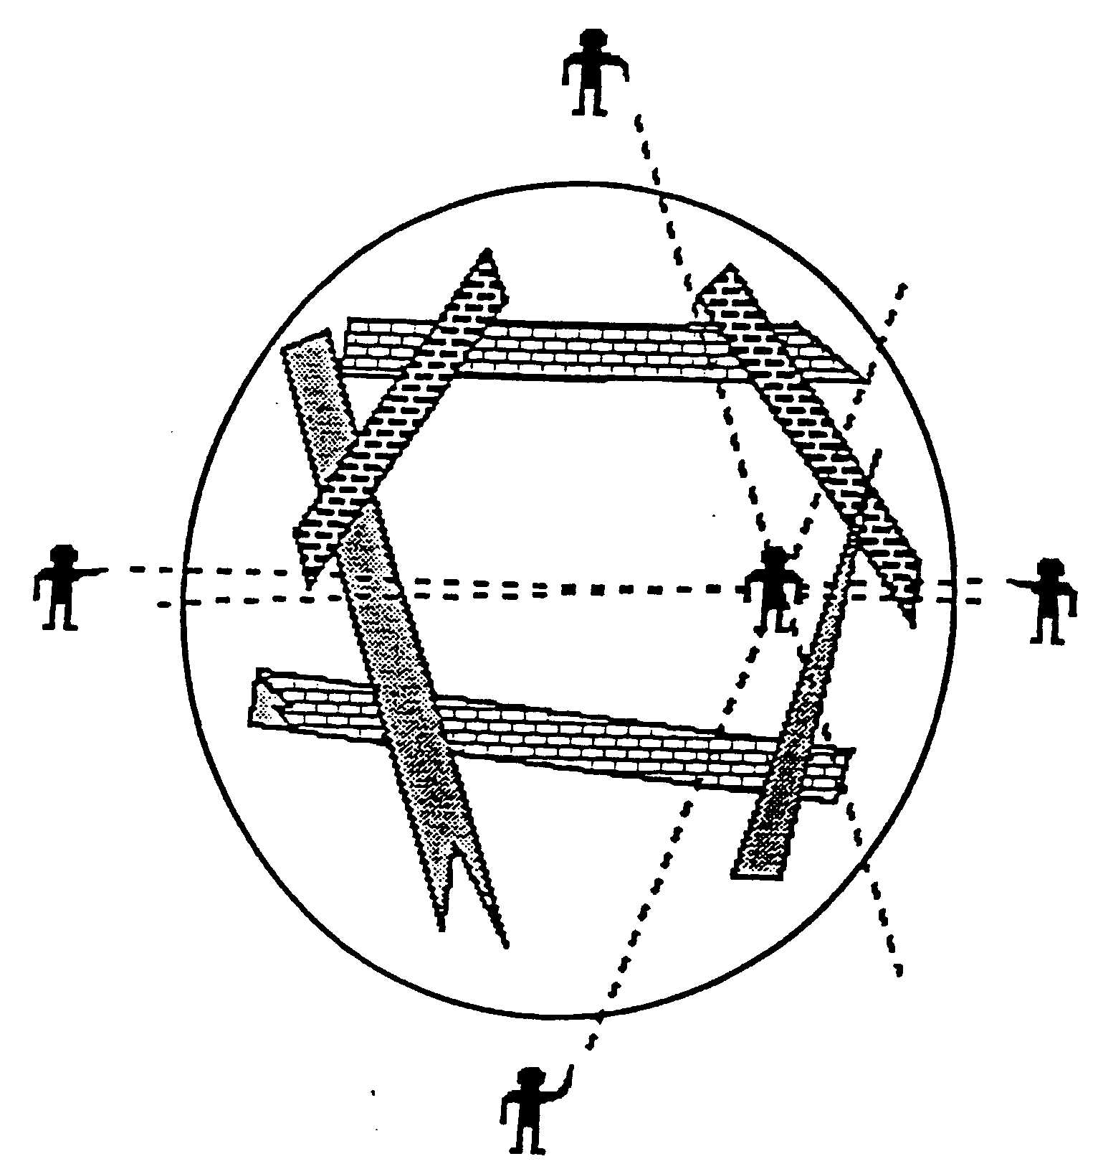
- Place rescuers in calling and listening positions around the search area
- Rescue team leader calls for silence and all work in the area stops
- Go "around the clock" each rescuer calls or taps some object
- All rescuers listen and try to get a "fix" on any sound they may hear
- Any sound heard should be verified with at least one additional "fix" from another angle
Search Methods and Marking
For a Known Location of Victim

Go the most direct and safest route to the victim.
For Unknown Location of Victim

Multiple Rooms
Entering : Go Right and stay right
Stay in contact with the wall
Exiting: Go Left and stay left
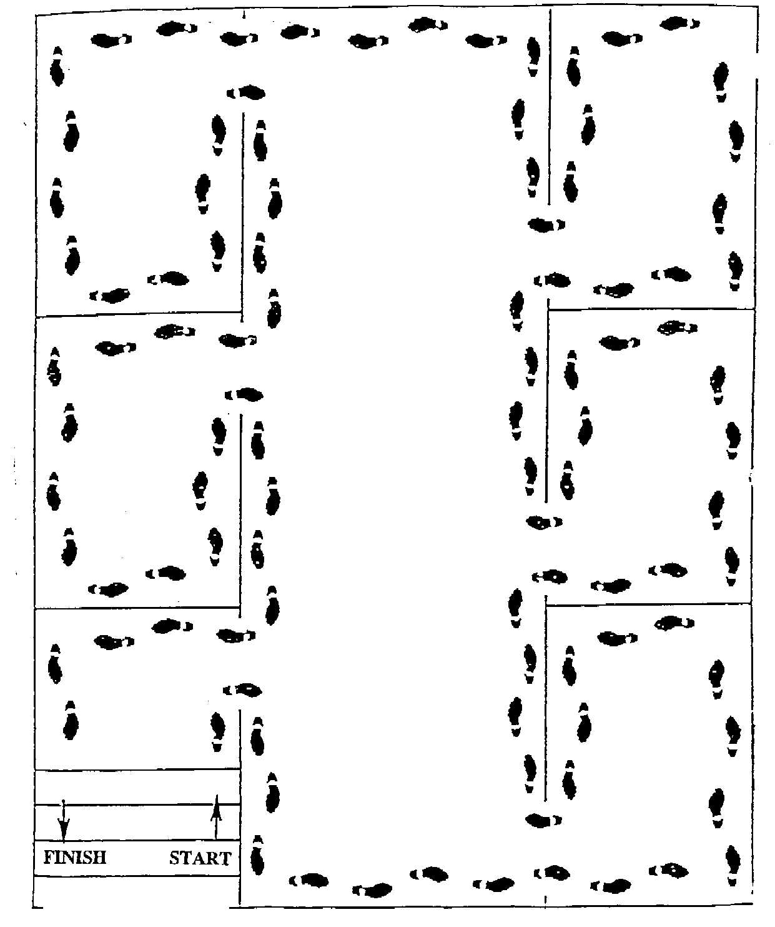
Stay in contact with the wall
Large Open Areas
Line Search
Spread team members straight across the open area
Slowly walk through the area to the other side
Team members on the ends of the line search perimeter rooms using "go right-stay right" method.
Search Markings
Must be easy to read, easy to make, easy to understand
Use chalk, paint, crayon, or tape
Start the marking symbol when you enter the room or structure
Complete the marking symbol when you leave the room or structure
Make this mark when you ENTER structure or room
DATE/TIME
COMPLETE
Complete the mark when you EXIT the structure or room then identify victims or hazards
HAZARDS
TEAM
NUMBER
VICTIMS STILL INSIDE & CONDITION

Safety & Security Team
Team Leader
Member
Member
Member

Responsibilities

Checklist - Report to Operations Section Chief
- Immediately following evacuation, secure all site buildings: lock doors and gates
- Cordon off any areas with apparent structural damage or other danger
- Station team members at obvious access points to direct parents, fire, rescue, police.

Equipment/Supplies

- Master keys
- 2-way radios
- Barricades, rope, tape
- Pre-written placards & signs
- Site diagrams with each important area indicated

Additional Information
Interior Command Post Meeting Place
Exterior Command Post Meeting Place
Safety/Security Team Location
Other | Other

Security Systems & Procedures

Control of Doors
Current daytime access to buildings will be maintained unless the situation dictates a need to reduce access. Building Managers will ensure that each site is secure from after hours access at the close of each business day. Arrangements will be made by Admin/Finance for keypad entrances to be secured if appropriate.

Vehicles
A designated Administrator will assess, and if necessary, direct the assigning of vehicles to managers. Managers who drive District vehicles may be assigned to pick up staff at designated locations who wish to report to work but cannot acquire transportation. The Administrator will provide for a backup system for keys to District vehicles.

Grounds
The grounds surrounding the building are designed and maintained to provide safe access to and a safe environment for personnel, staff, and visitors.
Utility/Fire Team
Team Leader |  | Group
Member |  | 1
Member |  | 1
Member |  | 2
Member |  | 2

Responsibilities

Checklist - Report to Operations Section Chief

FIRE
- Confirm reported fires existence and location
- Carry out small fire suppression actions
- Immediately report discovery of larger fires to Team Leader
- Assist in evacuation or Search & Rescue as needed
- If necessary, secure and post area with "DANGER" placard following suppression of small fire

UTILITIES
- Check utilities according to pre-assigned area of responsibility
- Take whatever action is necessary to minimize danger and future damage

- Assess what services are still available (water, electrical, telephone, sewer lines, heating/ventilation, bathrooms, etc.)
- Report assessment to Section Chief
- Survey extent of apparent structural and site damage and report to Section Chief

Equipment/Supplies

- Fire Extinguishers
- Hard hats
- Goggles
- Pens/pencils
- Vest
- Leather Gloves
- Ax
- 2-way radio
- Utility shut-off tools
- Utility Shut Off Checklist/Location Diagram
- Rapid Assessment Form
- DANGER placards

Additional Information
Interior Command Post Meeting Place
Exterior Command Post Meeting Place

Fire Extinguisher Operation
P.A.S.S.
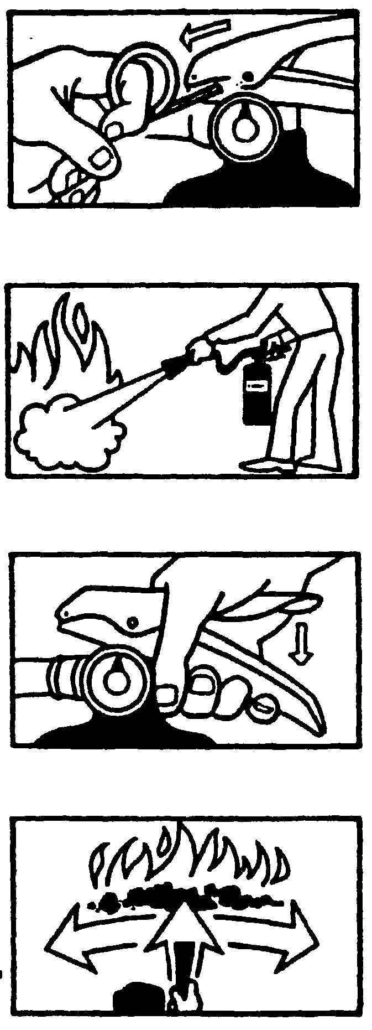
P.
PULL out the locking pin, breaking the seal.

A.
AIM nozzle or hose just in front of the base of the fire.

S.
SQUEEZE the trigger handle all the way.

S.
SWEEP discharge from side to side, moving front to back, across the base of the fire
Types of Fire Extinguishers
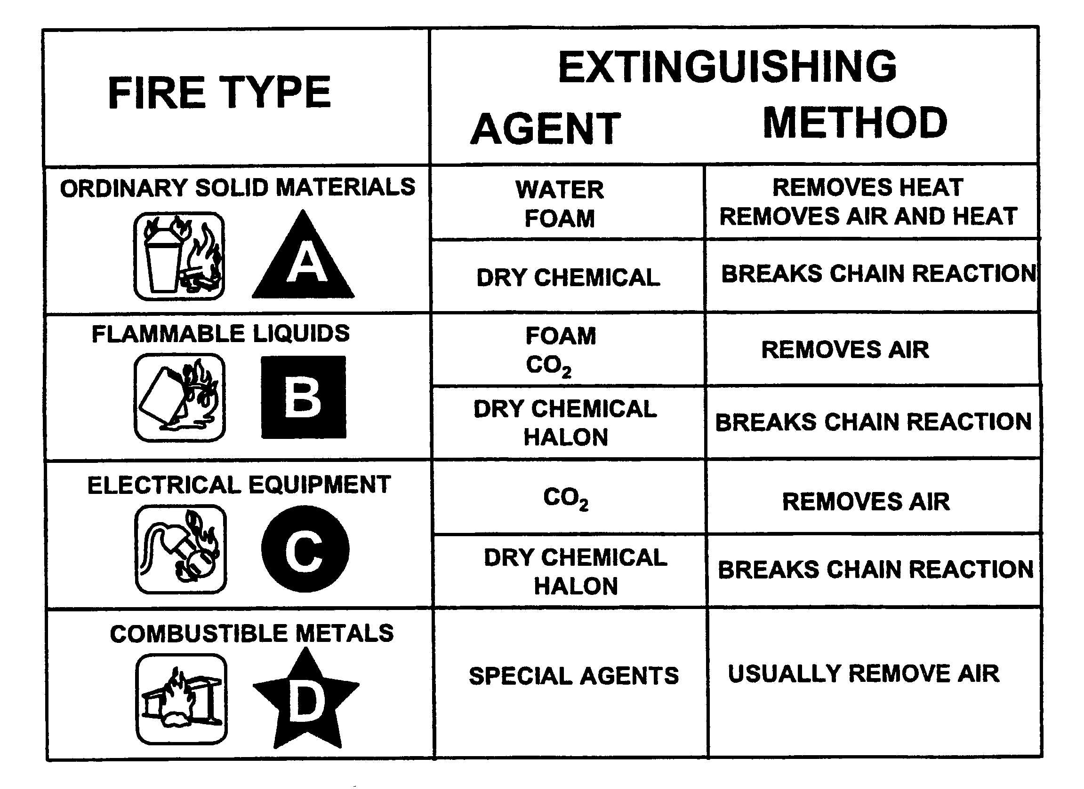
FIRE SUPPRESSION SAFETY

As a member of the Utility/Fire Team, fire suppression may be one of your roles. Remember - you will be unable to help anyone if your are injured through carelessness. Following is a list of safety rules:
- Do not attempt to suppress a fire that is clearly too large for the equipment at hand.
- Use safety equipment, including all-leather gloves.
- Work in a buddy system. No one should ever attempt to suppress a fire alone.
- Have a backup team. Unplanned events can occur when firefighting. Have backup available in case help is needed.
- Always have two ways to exit the fire area.
- Approach smoke-filled areas cautiously.
- Feel closed doors with the back of the hand, working from the bottom of the door to the top. If the door is hot, do not open it.
- Confine the fire whenever possible by keeping doors closed.
- Stay low to the ground.
- Always know a second escape route.
- Use natural ventilation to clear smoke.
- Maintain a safe distance from the fire. (Know your fire extinguisher's effective range.)
- Move around the perimeter of the fire to maximize coverage of the extinguishing agent.
- Overhaul to prevent rekindling of the fire.

Utility Shut-Off

Shutting off the Gas Meter Valve

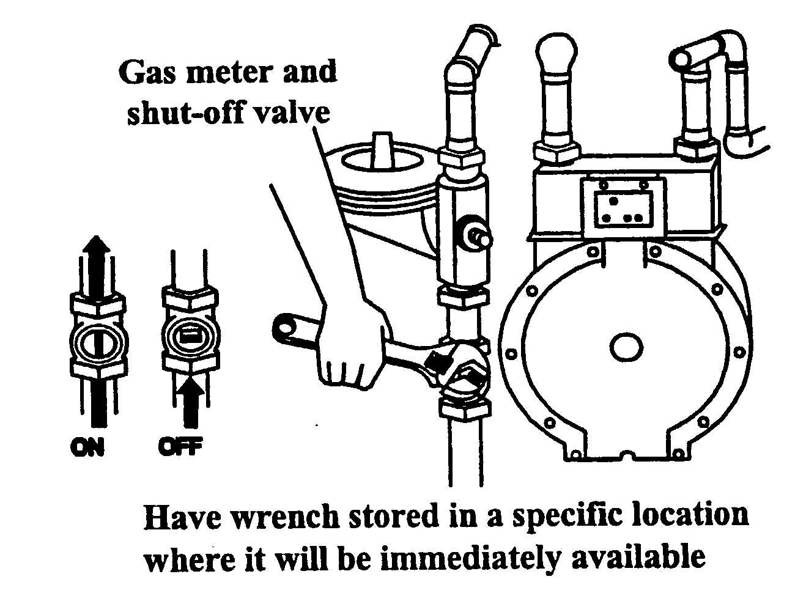
After determining that natural gas is leaking (smell, sound, fast meter dials), locate the gas meter. Check the gas valve to see if it is still open. Adjust the wrench on the valve for a snug fit. Turn the valve until it points across the pipe (perpendicular to the pipe direction). Check to see if the gas leak has stopped.

Shutting off the Electricity

After determining that an electrical problem exists, locate the electrical panel that controls the area. Ensure that the electrical control switches are not already in the "OFF" position. Sometimes a short circuit will shut off (pop) the switch to the "OFF" position. You don't want to turn it back "ON". Start with the small switches near the bottom and then turn off the main switch last. Ensure all switches are in the "OFF" position.
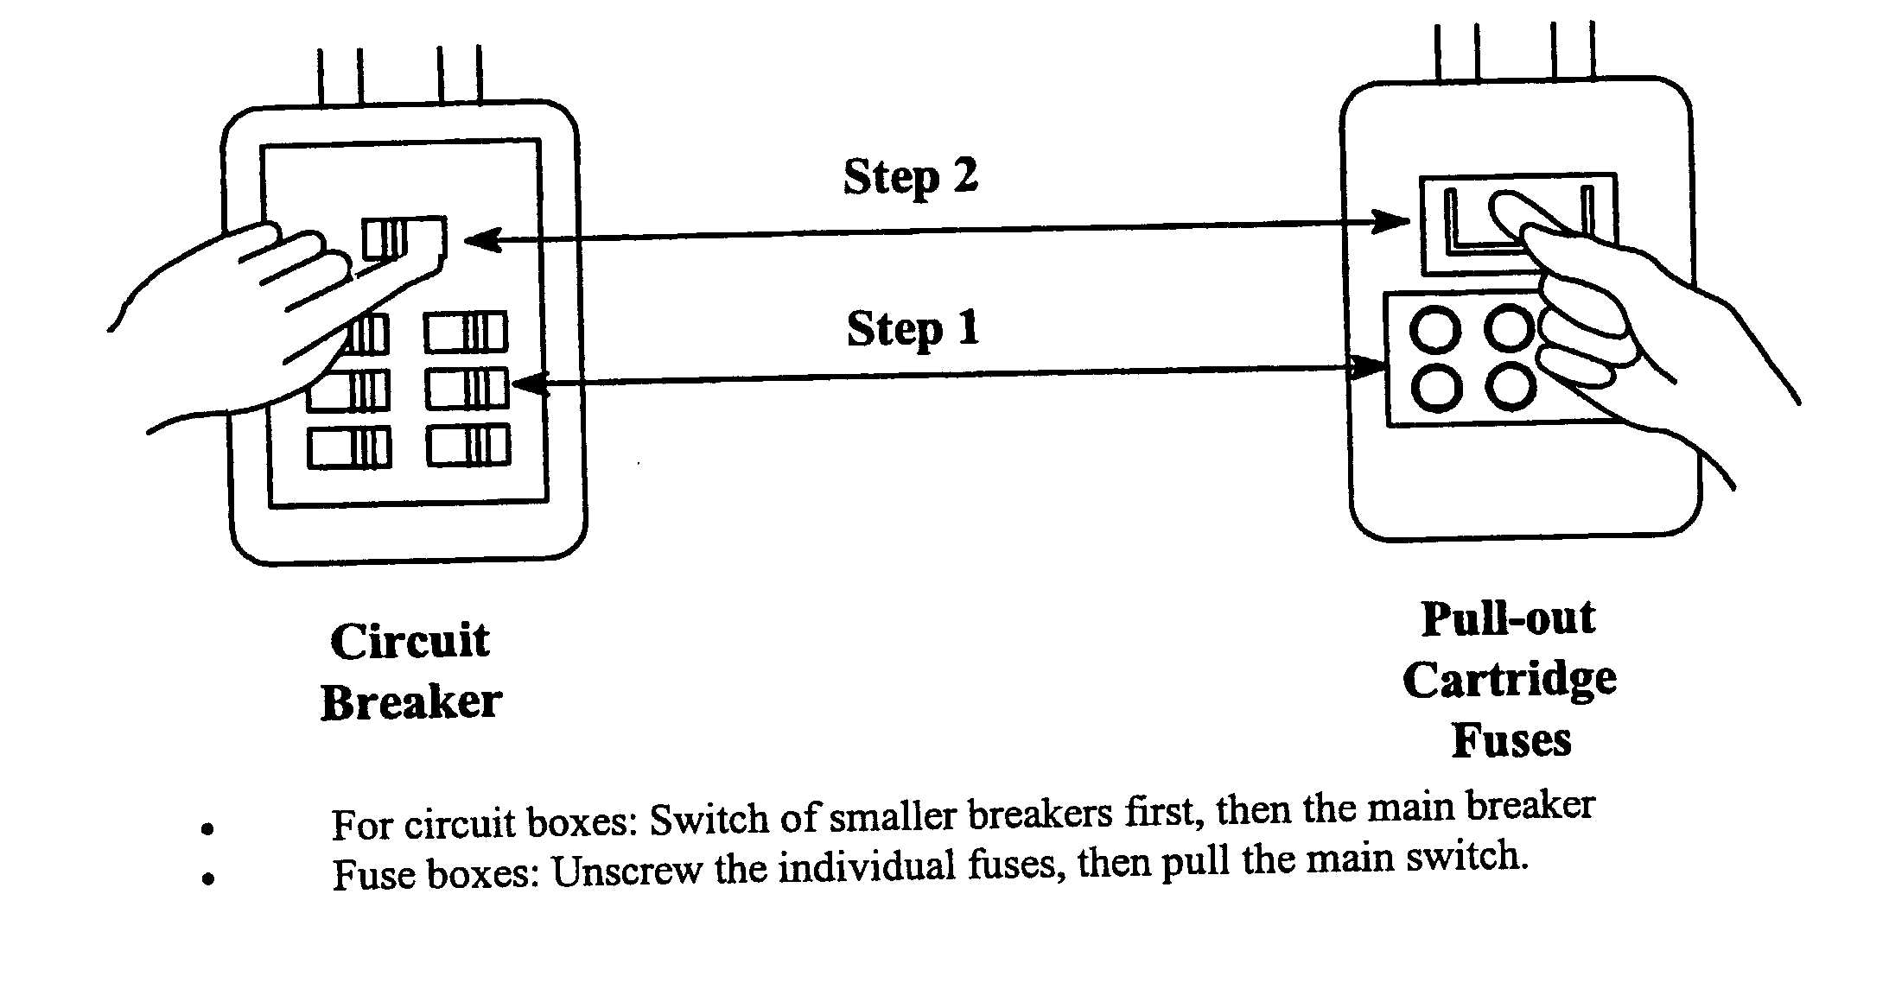
Shutting off the Water Valves

After determining that water is leaking (sound, fast meter dials), locate the water bib valve or water meter. Turn the valve to the right until it stops.
(RIGHT to tight, LEFT to loose)

Utility Shut-Off Locator
(insert a drawing or map or photographs showing locations of vital utility shut offs and how to operate valves and switches)

Support Team
Team Leader
Member
Member
Member

Responsibilities

Checklist - Report to Logistics Section Chief
- Prepare to receive volunteers. Provide them with job description
- Set up sanitation facilities
- Monitor sanitation & properly care for waste until it can be disposed of
- Gather all food/water supplies for distribution as needed
- Set up areas for shelter, sleeping, eating

Equipment/Supplies

- Aprons
- Rubber Gloves
- Eating Utensils
- Written instructions to parents
- Volunteer job descriptions
- Pens/pencils
- Water
- Plastic Trash Bags
- Blankets

Sanitary Facility Materials

- Poles
- Rolls of electrical wire (12 gauge)
- Black polyethylene sheeting
- Stainless Steel Clamps
- Portable "jons"
- Spare "jon" bags
- 5-gal urinal buckets
- 5-gal bucket liners
- Toilet paper and holders
- Disposable hand-wipes

Additional Information
Interior Command Post Meeting Place
Exterior Command Post Meeting Place
Shelter Location

Outdoor Sanitation Facility Location | Other

Outdoor Sanitary Facility Set-up Instructions

- Start by inserting at least 6 poles in the ground in a 4 foot by 6 foot rectangle.
- Wrap wire securely around poles approximately 4 to 4 1/2 feet above where the poles are be buried.
- Stretch wire tightly between and wrap each pole before going on to the next.
- Hang 5-foot wide strips of black polyethylene sheeting over the wire and clamp )like a clothespin) using the stainless steel clamps.
- Leave a little extra on the bottom as it may be necessary to apply weights between posts to keep from blowing in the breeze.
- Leave one section without sheeting to serve as an entrance.
- Set up portable johns, urinal buckets, and toilet paper holders inside enclosure.
- Set up a hand washing or hand-wipe station at the enclosure entrance/exit.
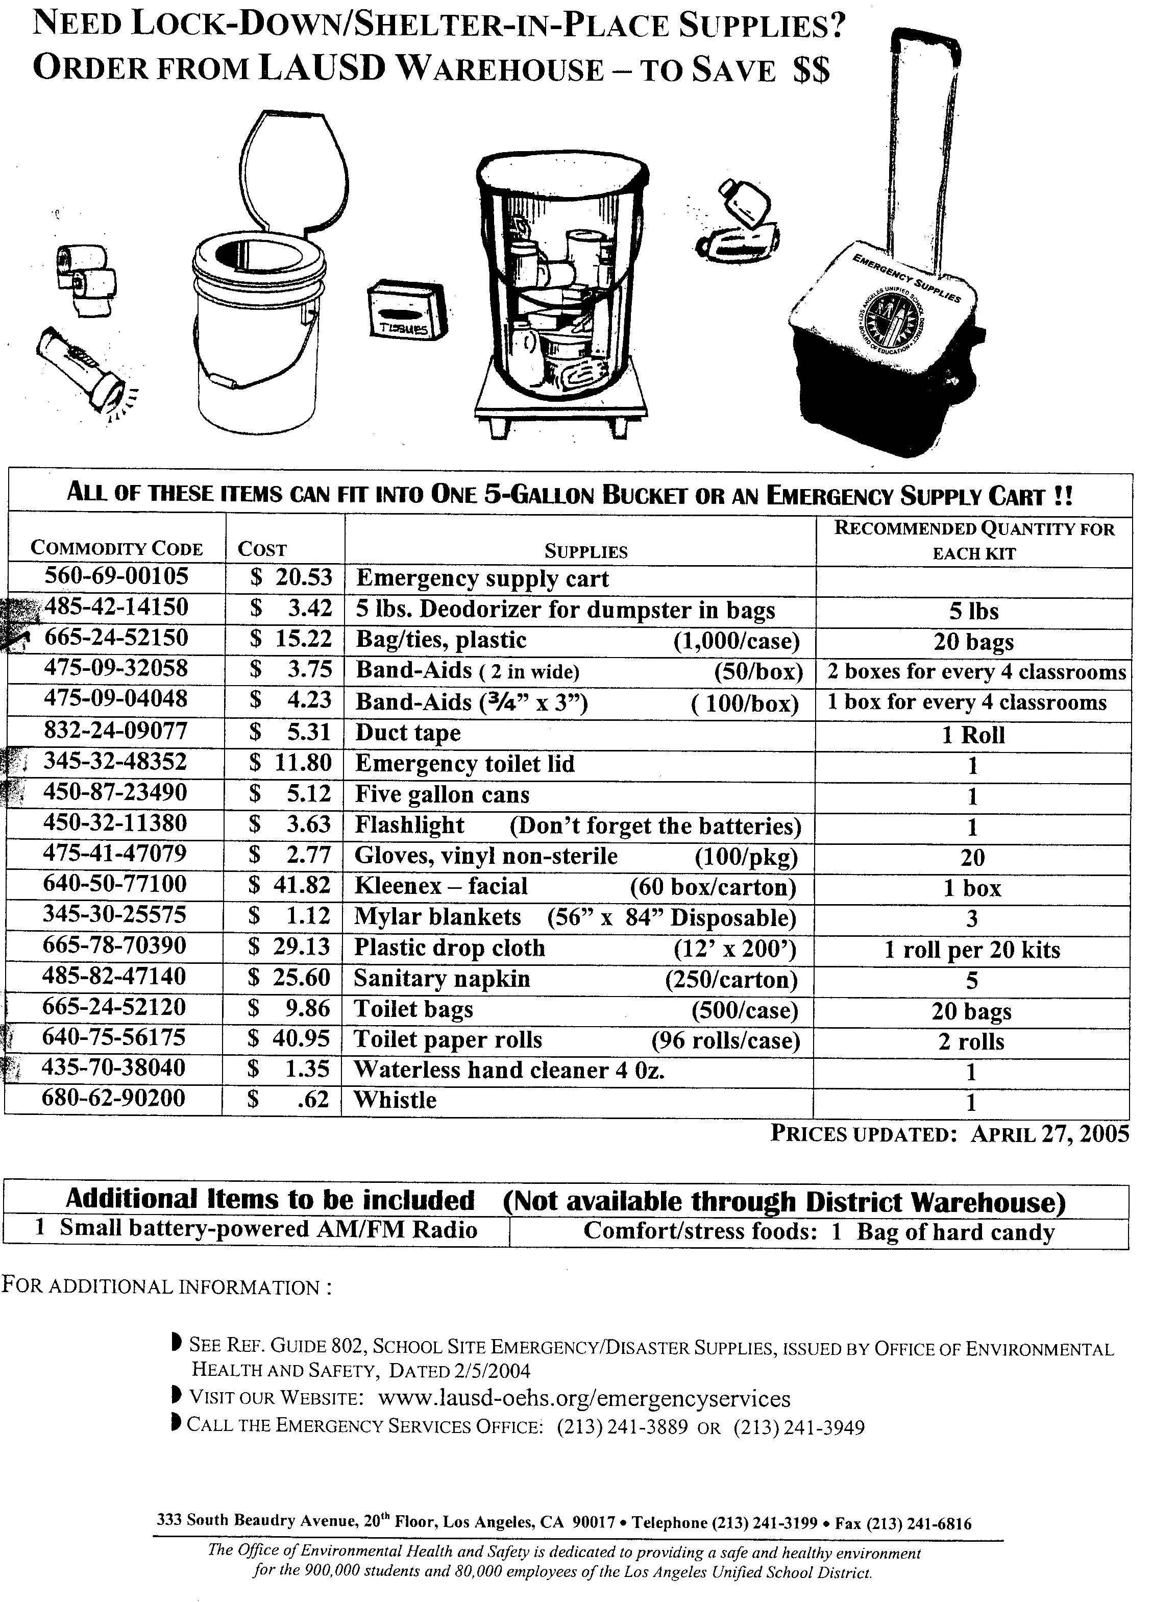

Communications Team
Team Leader
Member
Member
Member

Responsibilities

Checklist - Report to Logistics Section Chief
- Locate and distribute all 2-way radios, bullhorns, whistles
- Maintain spare batteries
- Establish central point for command post communications
- Take messages, prioritize (1) life-threatening, (2) property threatening, (3) non-emergency and distribute to appropriate section chiefs
- Keep communications log
- Make periodic reports to Logistics Section Chief

Equipment/Supplies
- General logs
- Facility Map
- Message forms
- Pens/pencils
- Extra batteries for portable radios, etc.

Additional Information
Interior Command Post Meeting Place
Exterior Command Post Meeting Place
Location of radios
Other | Other

Emergency Communications

Emergencies within a facility:

Internal communications will be via:
- Public address systems.
- Message runner.
- Telephone/emergency radio to administration offices.
- External communications will be via:
- Key communications network.
- News bulletins, as needed, by appointed personnel only.

Emergencies affecting two or more facilitys:

Inter-District communications will be via:
- Telephone network, if operable.
- Radio system for internal communications.
- Superintendent or designee and/or Administrator will release information to news media, KLCS, and prepare necessary bulletins.
A Crisis Communications Center will be established to collect and release information if the emergency is of a continuing nature.

When using the radio system:
- Firmly push down button to transmit, wait several seconds, then speak calmly and clearly into the mouthpiece. State numbers singly, such as "five-one," not "fifty-one."
- Unit to Base
- Identify yourself by unit number to Base.
- Base will respond to your unit number.
- Give message, after transmission is complete. Base will end with (base number)clear
- Unit to Unit
- Use unit number to begin and end transmissions.
- Use Unit number to begin and end transmissions.

DO NOT interrupt when someone is transmitting exception for emergency information.

- Portable units should remain in charger when not in use.
- Portable units keep a usable charge for 8 to 12 hours.

Administrator and/or designee will direct the use of hand-held radios within facilities.

Briefings/bulletins will be necessary in a continuing emergency, especially when facility remains open.
- Use established communication channels to keep employees, client/detainees, parents, key communicators and community informed.
- Keep secretary briefed on situation changes and what to tell people who phone the Facility.
- Hold briefings with employees, client/detainee leaders and other key communicators.
- Enact telephone tree to quickly communicate updates.
- Prepare bulletins to distribute to employees, client/detainees, parents and key communicators, as needed.
Status Form
Staff Member |  |  |  | Room |  | Date |  | Time
Staff Substitute
Assistant
Volunteer
Volunteer
Client/detainees
Number absent from facility | Number at First Aid Station |  | Number Missing or Unaccounted For |  |  |  | Number With Me Now
Injured
Name |  | In Assembly Area (√) | At First Aid Station (√) |  | Nature of Injury
Missing
Name |  |  | Last Known Location
(continue on back)
Personnel Accountability Team
Team Leader
Member
Member
Member

Responsibilities

Checklist - Report to Planning & Intelligence Section Chief
- Establish reunion points at each facility access location
- Manage sign-in.-out procedure for facility

Equipment/Supplies

- Rosters
- Map of assembly area (Evacuation Plan)
- Pens/pencils
- 2-way radio
- Sign-in/out Log

Additional Information
Interior Command Post Meeting Place
Exterior Command Post Meeting Place
Assembly Areas

Sing-In/Out Log
For use by the Personnel Accountability Team
Time | Name | Departed from | Destination

Rapid Assessment Team
Team Leader
Member
Member
Member

Responsibilities

Checklist - Report to Operations Section Chief
- Check evacuation routes for safety. Advise alternate routes if necessary
- Check client/detainee assembly areas for gas/water pipe ruptures, downed power lines, etc.
- Inspect all facility buildings for damage. Report structural problems such as cracks in walls, damage to classrooms, science labs and other areas to the Command Post using Rapid Assessment Forms
- Cordon off dangerous areas with barrier tape/danger signs
- Inspect after each earthquake aftershock - report to Command Post

Equipment/Supplies

- Hard hats
- Facility Map
- Rapid Assessment Forms
- Barrier tape
- Flashlights with extra batteries
- Evacuation Plan

Additional Information
Interior Command Post Meeting Place
Exterior Command Post Meeting Place
Other | Other
Los Angeles Unified School District
SCHOOL/SITE PRELIMINARY DAMAGE REPORT (PDR)
(Please use this form to report your status to the Local District)

School/Site: |  |  |  |  |  |  |  |  | Location Code:
Date: | Time: | Person in Charge:
Contact Information (How can we call you back for additional information?):
Please answer the following:
Has anyone died from this incident? |  |  | - Yes |  |  | - No |  | # of Students |  |  |  | # of Staff
Are there any injuries? |  |  | - Yes |  |  | - No |  | # of Students |  |  |  | # of Staff
How many buildings at your site are visibly damaged? |  |  |  |  |  |  | Explain the type of damage you observe?
Summarize your actions thus far: |  |  |  |  |  |  |  | Do you have the following?
 |  |  |  |  |  |  |  | Power |  |  | - Yes |  | - No
 |  |  |  |  |  |  |  | Water |  |  | - Yes |  | - No
 |  |  |  |  |  |  |  | Phone |  |  | - Yes |  | - No
 |  |  |  |  |  |  |  | Radio |  |  | - Yes |  | - No
Where is your current evacuation assembly area?
What are your most critical issues?
What are your other problems?
What assistance do you need?

Building Detailed Evaluation Form

Building Name and Address
________________________________________
________________________________________
________________________________________
________________________________________

Sketch

SEND COPY OF THIS FORM TO COMMAND POST

Records Team
Team Leader
Member
Member

Responsibilities

Checklist - Report to Administration & Finance Section Chief
- Locate and provide all forms and related materials to Section Chiefs and Team Leaders
- Set up and maintain files of all incoming documentation
- Provide clerical assistance to Command Post and Section Chiefs
- Document injury and illness records
- Take messages, prioritize (1) life-threatening, (2) property threatening, (3) non-emergency and distribute to appropriate section chiefs
- Keep communications log
- Make periodic reports to Logistics Section Chief

Equipment/Supplies

- General logs
- Facility Maps
- Message forms
- Pens/pencils
- Client/detainee Release Authorization Forms
- Rapid Assessment Forms
- Class Status Forms
- Emergency Triage Cards
- First Aid Care Log Forms
- Activity Log Sheets
- File Folders
- Office Supplies
- File Boxes

Additional Information
Interior Command Post Meeting Place
Exterior Command Post Meeting Place
Other | Other
Storing Supplies
After a disaster, it may not be possible to leave a facility. It also may not be possible for emergency responders to get to the facility. People may spend 24 hours or longer on the premises, without any material help from outsiders.
Stocking supplies -- first aid kits, water, tools, and food -- in a secure place is therefore an important part of the facility preparedness plan. Assuring that those supplies are fresh and up-to-date is also crucial. It is a good idea to keep inventories of supplies and written records of where they are.
It works well to assign the procurement, storage and maintenance of specific supplies to the teams with those particular responsibilities after a disaster.
Basic Supplies

These are the very necessary basic supplies:
- Adequate first aid supplies
- Flashlights and extra batteries
- Extra fire extinguishers
- Emergency search and rescue tools
- Battery powered radios and extra batteries
- Enough liquids for all the people in the facility (at least 1 gallon of water per person for 3 days)
- Space blankets or regular blankets
- Heavy duty plastic bags
- Sanitation supplies
- Useful non-prescription drugs
It's not necessary to procure everything at once, but facilities should try to accumulate supplies incrementally. Priorities in acquiring supplies should correspond to which ones will be most important immediately after the disaster and as time goes on. For example, first aid is more important than water, and water is more important than food.

Supply Acquisition Checklist
The following is a checklist facilities can use to acquire, store and maintain disaster response supplies:
- Using the attached master list of Equipment and Supplies by Team, determine which supplies are most critical, decide on needed quantities, and estimate costs.
- Using the attached Basic Facility Supplies and Suggested Emergency Supplies and Equipment, have each team meet and develop a plan for acquiring what is necessary. Assign particular procurement and storage responsibilities to team members.
- Develop a schedule for each team to follow in acquiring the supplies, finding appropriate storage space for them, and checking and replenishing them periodically.
Equipment and Supplies by Team

Incident Command Team

- Roster of employees
- Emergency assignment list
- Map of facility/Facility
- Site Disaster Plan
- Clipboard
- Walkie-talkie
- Bullhorn
- Battery-operated radio/batteries
- Paper & writing implements
- Whistle
- Emergency Lighting
- Hard hats
- Activity log sheets
- Message forms
- General Logs

First Aid Team

- Emergency triage tags
- First aid equipment (blankets, stretchers)
- Flashlights
- Paper & writing implements
- Clipboard
- Rubber gloves
- Plastic trash bags
- Masks/Face shields
- Gowns/aprons
- Water
- First aid care logs

Search and Rescue Team

- Roster of employees
- Map of facility/facility
- Fire extinguishers
- Flashlights
- Walkie-talkies
- Master keys and bolt cutters
- Crowbars and fire axes
- Shovels and ropes
- Gloves, goggles, face masks
- Hard hats, vests
- Sturdy shoes/boots
- Clipboards
- Blankets
- Duct tape (for marking)

Safety & Security Team

- Map of facility
- Master keys
- Walkie-talkies
- Writing implements
- Identification badge or armband
- Barricades, rope, tape
- Pre-written signs and placards

Utility/Fire Team

- Fire extinguishers (CO2, water, & A,B,C type)
- Hard hats
- Goggles
- Leather Gloves
- Vest
- Shovels and axes
- Walkie-talkie
- Tools for shutoff of utilities
- Utility shut-off checklists
- Rapid assessment forms
- DANGER placards

Support Team

- Supply storage map
- Sanitation supplies
- Paper & writing implements
- Food and Water
- Aprons
- Rubber gloves
- Eating utensils
- Written instructions to parents
- Water
- Plastic trash bags
- Blankets

Sanitation Facility Materials
- Poles
- Rolls of electrical wire (12 gauge)
- Black polyethylene sheeting
- Stainless steel clamps
- Portable "jons"
- Spare "jon" bags
- 5-gal urinal buckets
- 5-gal bucket liners
- Toilet paper and holders
- Disposable hand-wipes

Communications Team
- General logs
- Facility map
- Message forms
- Pens/pencils
- Extra batteries for portable radios

Personnel Accountability Team

- Master keys
- Evacuation Plan
- Map of facility
- Employee/Visitor Rosters
- Bullhorns
- Walkie-talkie
- Paper & writing implements

Rapid Assessment Team
- Hard hats
- Facility maps
- Rapid assessment forms
- Barrier tape
- Flashlights with extra batteries
- Evacuation plan

Records Team

- General Logs
- Facility Maps
- Message Forms
- Pens/pencils
- Employee release authorization forms
- Rapid assessment forms
- Class status forms
- Emergency Triage Cards
- First aid care log forms
- Activity Log Sheets
- File folders
- Office supplies
- File boxes
- Injury Forms

Basic Facility Supplies

Disaster Medical Supplies
Additional medical supplies should be provided for use in disasters only. Disaster medical supplies can be specifically packaged in units to be used when necessary in an emergency. The disaster supplies should not be used for day-to-day needs. The disaster supplies should be packaged in units to serve personnel as follows: (Sites can order an emergency first aid kit for 100 people through the LAUSD warehouse – Item# 345-32-48275.)
1 to 750 people 1-Kit
750 to 1500 people 2 kits

Medical Supply Kit (Up To 750 People)

Alcohol Prep Pads (Box of 50) 3
Alcohol, Isopropyl Rubbing (pint) 25
Ammonia Inhalant (Box of 10) 1
Applicator, Sterile 3" (Box of 50) 1
Baking Soda (Box) 1
Bandage Scissors, 7 1/4" 1
Bandages, Adhesive (Asst Box) 1
Bandages, Elastic 3" 10
Bandages, Elastic 6" 10
Bandages, 4-tailed 10
Bandages, Triangular 10
Chlorinating Agent (100s) 3
Diapers, disposable (pkg) 1
Eye droppers 10
Eye patches, sterile 3
Facial tissues (packets) 20
Flashlights with batteries 1
Gauze pads, Sterile 4X4 20
Gauze roll, 1" 10
Gauze roll, 4" 2
Non-aspirin tablets & chewables 1
Paper towels (pkg) 1
Plastic bags (pkg) 1
Plastic wrap (lg roll) 20
Resuscitubes (1ea child & adult) 1
Safety pins (pkg) 2
Salt (1-lb) 1
Sanitary napkins (bx) 2
Sheets 1
Soap, liquid & waterless 1
Splints, cardboard (18") 10
Splints, cardboard (24") 3
Stretchers 1
Tape, adhesive (1"x10yd) 24
Tape, adhesive (1/2"x10yds) 1
'Tape, adhesive (2"x10yds) 2
Tongue depressors (pkg) 1
Tweezers, squeeze tip 10
Vaseline (jar) 1
Water, Sterile (5 gal plastic) 1

Non-Medical Emergency Supplies & Equipment

Axes 4
Space Blankets 30
Bullhorn (batteries) 2
Can Opener (manual) 3
Coleman Lantern 2
Lantern Fuel (gal) 1
Crowbars 4
Cups (paper/plastic) 200
Fire Extinguishers 4
Flashlights (batteries) 10
Hammers 4
Hardhats 10
Hoses, garden (50') 4
Knives, heavy duty 4
Light sticks 20
Masking tape 4
Matches, water proof (box) 4
Pails 4
Picks 4
Plastic Garbage Bags (box) 1500
Plastic Sheeting (4'x100') 1
Plastic Water Barrel (55gal) 2
Rope, nylon (100') 4
Saws, hand 4
Screwdrivers 4
Shovels 4
Stretchers 4
String (roll) 4
Tarps (9x12) 10
Toilet paper (pkg.) 10
Transistor Radio, AM/FM 4
Walkie Talkies 4
Wooden poles (6') 20
Wire (roll) 10
Wire cutters 4
Wrenches, adjustable 4

Essential Shelter Supplies

- First Aid Kits
- First Aid Text Books
- Emergency generator
- Sanitary supplies
- Blankets
- Cots (mats, rugs)
- Cleaning equipment
- Shelter identification sign

Water for Three Days (minimum)
One-gallon bottles filled to the top with fresh water and eight drops of chlorine disinfectant (sold commercially), or five-gallon sterile, sealed containers.
NEEDS: 1-quart drinking water per person per day
5 gallons all-purpose water per person per day
NOTE: Hot water tanks and toilet tanks contain emergency water

Water:
Water for drinking is the most important. Cooking, bathing and washing take additional water. Besides emergency water stored, it can also be from other sources such as hot water heaters, toilet holding tanks (that do not contain chemicals). Do not flush toilets until you know the state of the sewers and the water availability.
If you have water pressure after the disaster start filling additional containers. It can be stored for bathing and washing, for drinking the water should be purified to eliminate any contamination.

How to Purify Water:
Boiling: Boil vigorously for 1-3 minutes. To improve taste, pour from one container to another several times.
Purification Tablets: Available at any drug store. Follow directions on package.
Bleach Purification: Liquid household bleach can also be used. It must contain hypochlorite, preferably 5.25%. Add according to the table below then stir or mix.
Purification Guidelines:
AMOUNT OF WATER CLEAR WATER CLOUDY WATER

1 QUART 2 DROPS 4 DROPS
1 GALLON 8 DROPS 16 DROPS
5 GALLONS ½ tsp. 1 tsp.

Food Supplies for Three Days (minimum):

Suggested canned foods:
Luncheon meat, ham, nuts, fruits, fruit juices, vegetables, refried beans, date-nut rolls, soft drinks.

Suggested dry foods:
Cereals, peanut butter, crackers, freeze-dried foods, granola or energy bars, dehydrated potatoes, instant coffee, tea, milk powder (or tetra boxes), sugar, candy, powdered fruit juice mixes, soup and bouillon (also comes in tetra boxes)

Suggested equipment and supplies for food service:

- Can openers (non-electric)
- Pots, pans, serving utensils
- Coffee pots
- Paper cups, plates, bowls, napkins, towels
- Plastic utensils
- Serving Trays
- Camp stoves or hibachis, and fuel*
(* check fire code on fuel storage. Provide adequate ventilation)

If you do not have a Cafeteria in your facility:
Have personnel bring an earthquake kit to their area. Each kit should have such things as granola bars, cans of juice, packages of dried fruit—items that have a long storage life and are not easily squashed. The amount of food should be sufficient to quell their hunger pangs for 72 hours.

If you do HAVE a Cafeteria:
Make sure you date and rotate your food supplies so that they do not get old. When opening cans of fruits or vegetables, do not throw away the liquid in if there is a water shortage. Do not drink or eat anything from open containers near shattered glass. Strain suspected liquids through a clean handkerchief.
After a disaster, use the food in the refrigerator and freezer first. Although the disaster may not interrupt power, shortages may have occurred elsewhere and may have caused loss of electric current.

